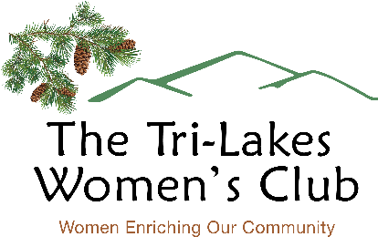

2023 GRANT APPLICATION

Name of Applicant: ________________________________________________________
Address: ________________________________________________________________
IRS Employer Identification Number (EIN): ______________________________________
Contact name and title: __________________________________________________
Contact Phone #: ________________________________________________________
Contact Email: _________________________________________________________
Provide a detailed explanation describing how your organization and its services benefit the Tri-Lakes area. For example, a description of constituency and approximate number of Tri-Lakes area residents served.
Name of Project:
Goal(s) of Project:

Description of Project (you may include photos and other attachments):

Timeline for Tasks of Project:

How would a grant from TLWC be acknowledged?

Total Amount of Grant Request ($2,000 or less): ___________________________________

Description of requested items with highest priority items listed first.

ITEM | COST
SUPPORTING DOCUMENTATION (QUOTES, BIDS, ETC) IS REQUIRED FOR EACH ITEM.

____________________________________________________________________________
Signature of Applicant Date

____________________________________________________________________________
Signature, Executive Director/ Chief/ Principal Date

DEADLINE IS MARCH 15, 2023. (RECEIVED BY EMAIL: Granting@tlwc.net)

