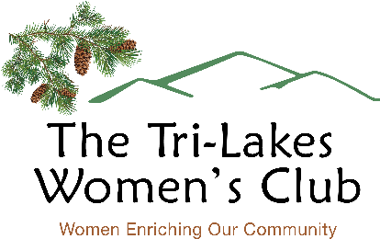

2023 GRANT APPLICATION INSTRUCTIONS

The Tri-Lakes Women’s Club (TLWC) will award funds to approved 501(c)(3) and 501(c)(4) non-profits and to public service organizations that provide significant services to residents of the Tri-Lakes area, as well as District 38 schools. Our grant program’s purpose is to fund specific items that would be difficult for an organization to purchase without our assistance.

- Awards are limited to $ 2,000 or less. All applications must be postmarked or submitted by email to granting@tlwc.net by March 15, 2023 to be considered.
- Applications with missing information will not be considered.
- Organizations that use paid telemarketers are not eligible to receive a grant.
- Sales tax is not reimbursable.
- Grant funds may not be used as reimbursement for items purchased before you are awarded a grant. (Purchases prior to May 19, 2023 will not be reimbursed.)
- TLWC grants are generally reserved for projects or programs. Items that will not be funded include general operating expenses (such as rent or salaries) and requests from pass through organizations.
- The service(s) provided by the grant applicant organization should be focused on the Tri-Lakes community. A detailed explanation describing how your organization and its services will benefit this community is required.
- Nonprofit applicants must be able to document their Federal Income Tax exemption status under section 501(c) (3) or 501(c)(4) of the IRS Tax Code.
- Organizations receiving grants are subject to on-site evaluation during the year following the award to see the value the award has provided to the organization.
- Information submitted to TLWC in reference to an individual organization’s grant will be kept strictly confidential.
- All applicants will be informed of the status of their grant request by June 1, 2023.
- Organizations awarded a TLWC grant must submit all receipts/paid invoices substantiating expenditures to the TLWC Grant Chair no later than January 15, 2024. Earlier submission, when possible, is appreciated.

Email questions to Anne Campbell, Grant Committee Chair, at granting@tlwc.net.

